Name : Yomna Taher Abdallah

**Sales Data Analysis**

[**Assessment Questions**](https://github.com/intern2grow/sales-data-analysis/blob/main/README.md#assessment-questions)

1. What was the total revenue generated by the company over the course of the year?

>> Total revenue = 758330.0 .

1. Which product had the highest revenue? How much revenue did it generate?

|  |  |
| --- | --- |
| Product | Revenue |
| Smartphone | 434400 |

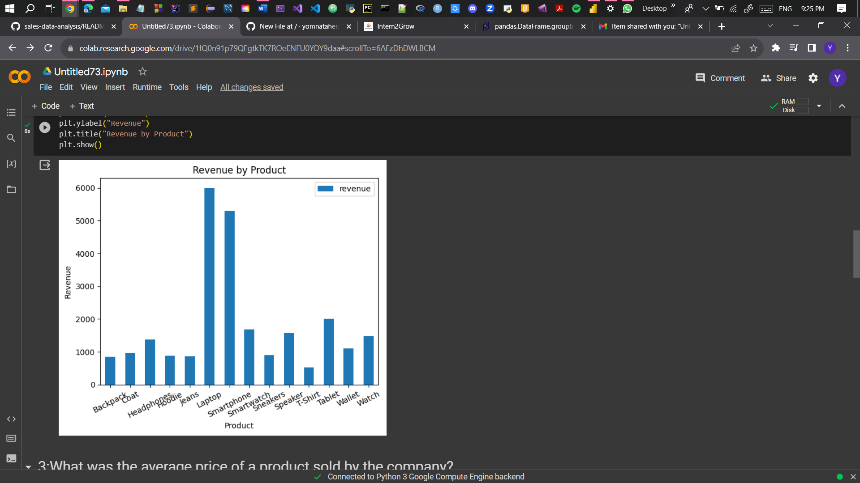

1. What was the average price of a product sold by the company?

>> Average price = 211.22615803814713 .

1. What was the total quantity of products sold by the company?

>> Total quantity = 5360.0 .

1. Which category had the highest revenue? How much revenue did it generate?

|  |  |
| --- | --- |
| Category | Revenue |
| Electronics | 516080.0 |

1. What was the average revenue per sale?

|  |  |
| --- | --- |
| Product | Revenue |
| Backpack | 850.000000 |
| Coat | 965.714286 |
| Headphones | 1384.615385 |
| Hoodie | 875.000000 |
| Jeans | 860.416667 |
| Laptop | 6000.000000 |
| Smartphone | 5297.560976 |
| Smartwatch | 1680.000000 |
| Sneakers | 900.000000 |
| Speaker | 1587.200000 |
| T-Shirt | 528.947368 |
| Tablet | 2000.000000 |
| Wallet | 1100.000000 |
| Watch | 1486.363636 |

1. What was the total revenue generated in each quarter of the year? (i.e. Q1, Q2, Q3, Q4)

|  |  |
| --- | --- |
| Quarter | Revenue |
| 1 | 182100.0 |
| 2 | 183970.0 |
| 3 | 197680.0 |
| 4 | 194580.0 |

-----------------------------------------------------------------------------------

Source code: <https://colab.research.google.com/drive/1fQ0n91p79QFgtkTK7ROeENFU0YOY9daa?usp=sharing>